|  |
| --- |
| Tab Tab Attack *20 pts general skills* |
| Description:  Using tabcomplete in the Terminal will add years to your life, esp. when dealing with long rambling directory structures and filenames: Addadshashanammu.zip |

1. Download the zip file from the description.
2. *cd* into the folder containing the download.
3. Unzip the file by typing in the terminal command *unzip Addadshashanammu*
   1. Notice on the left-side it says “creating” or “inflating.” Creating means that a folder/file path is being undergoing the unzip process, and “inflating” means that a file is undergoing the unzip process.
   2. Therefore, there are 7 folders, and in the last folder there is a file named “fang-of-haynekhtnamet.”
4. Navigate to the file by typing in the terminal command: *cd Addadshashanammu/Almurbalarammi/Ashalmimilkala/Assurnabitashpi/Maelkashishi/Onnissiralis/Ularradallaku/*
5. “fang-of-haynekhtnamet” is a shared library file type, so run it by typing the command *./fang-of-haynekhtnamet*
   1. The file type can be discovered by clicking your way through the GUI folder structure of the unzipped folders until you arrive at the file, and then right-click 🡪 properties 🡪 filetype is labeled next to “Type:.” Additionally you can type the command *file fang-of-haynekhtnamet* into the terminal at this step.
6. The flag will be generated via the terminal.

2

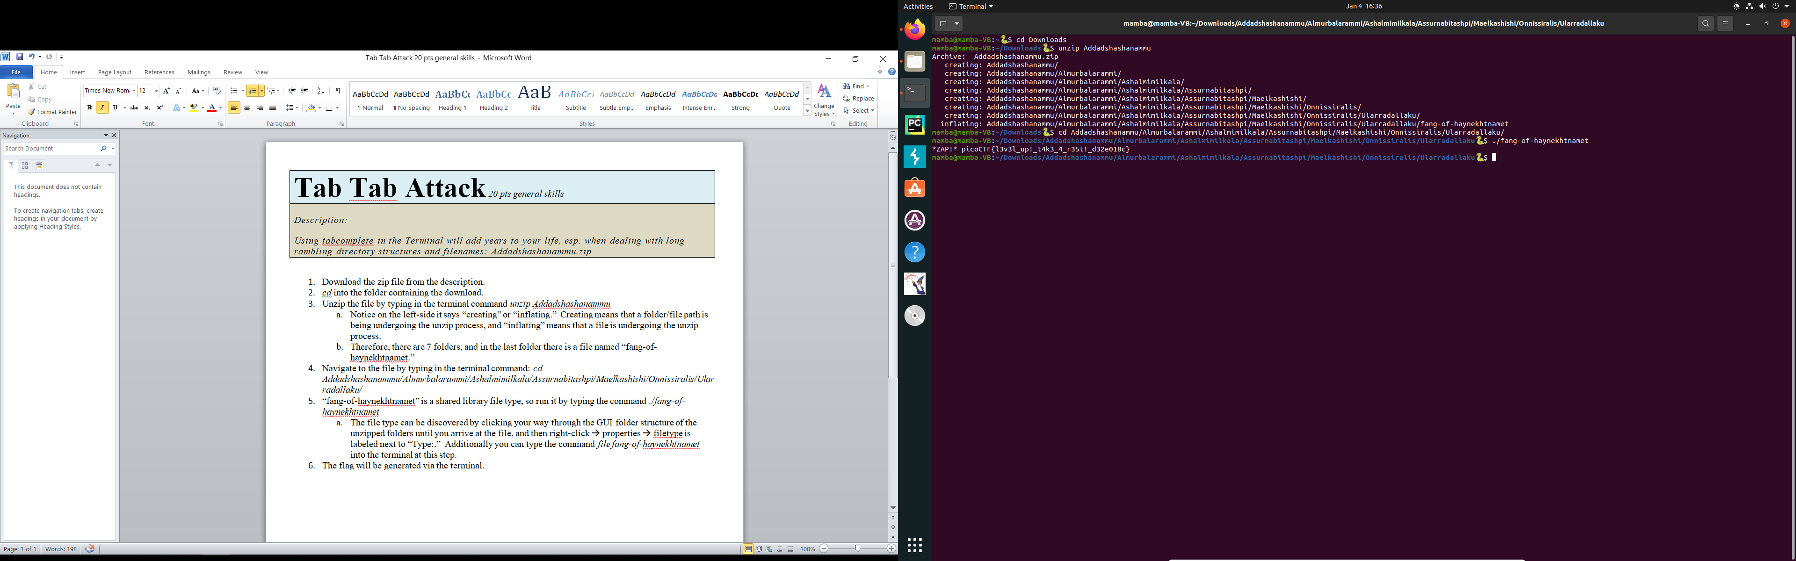

3

4

6

5